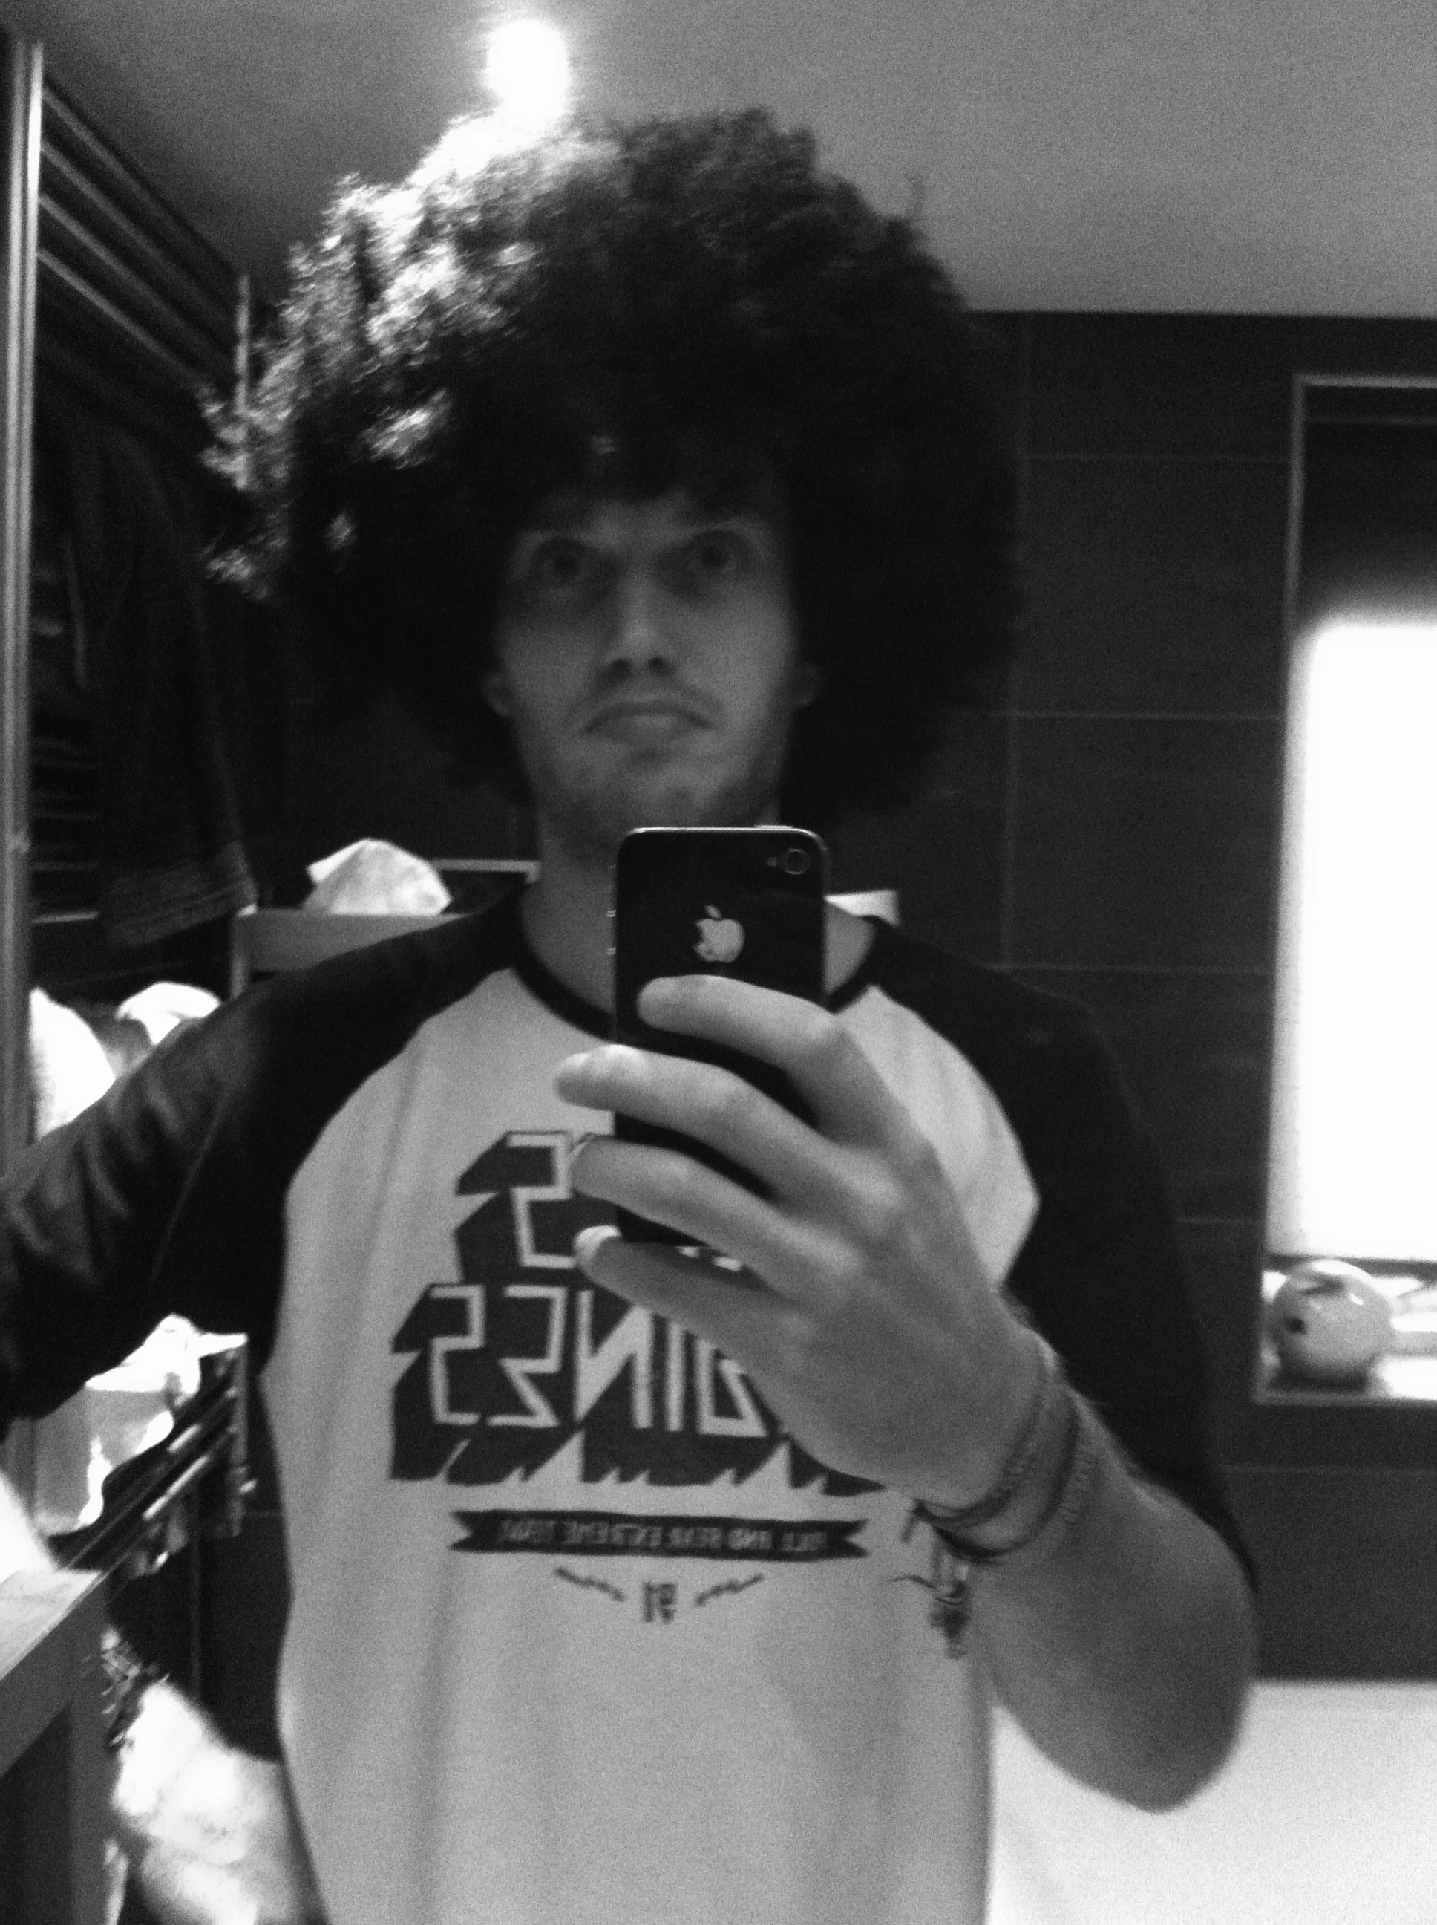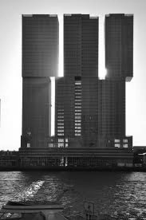

New police office on 15th street

Iniev nievni knerojnv onvoienr ni reno

Ergnin rinivr inkmvro r ormif ririnv rswe

Orrigj oeimr oej oje oo jsom oem ie.

This is Tim in his Free time. . . . Acting like a Fool.

15 december 2020, New york.

A Team of dutch event organizers have made up a whole new concept of organizing an event. The company, which is called Big Bird entertainment, is focussing on a concept where the audience can shape their own festival. Creative sharing is what they call it. The audience can request their favorite artist, layout of the festival, catering, theme’s and many more thing.

Tim Bronmeijer founded Big Bird entertainment in 2018, the year he graudated from college. In two years the company has exploded to a world wide leader in the event buisness. On 2018 Tim started his company alone, soon he hired some of his old fellow students. And now the dutchman is thinking about opening an office in New York city.

He will be in New York next month to see if there is room for their company to organize some events in the city. The New York city parlement have said that they look forward to working together with Big Bird entertainment, because they think this city is in need of some innovation.

If you want to here more you can order your tickets for a workshop Tim gives in New York on the 15th of January. For more information and tickets you can go to the Big Bird entertainment website

The Big Bird Entertainment office in Rotterdam.

New police office on 15th street

Iniev nievni knerojnv onvoienr ni reno

Ergnin rinivr inkmvro r ormif ririnv rswe

Orrigj oeimr oej oje oo jsom oem ie.

Dutch event organizers are spreading their new and innovative concept across the world

The New York Times